1.
Prove by mathematical induction.

3.
(iii) 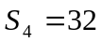

4.
(i) 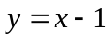 , 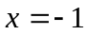
(ii) local minimum point : 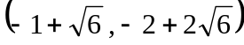 ; local maximum point : 